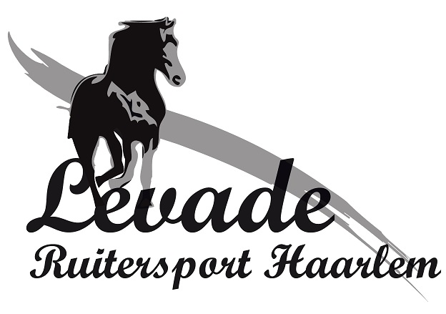
CARTRIDGE | TYPE & SIZE
50cc | Airbag Child S, M & L
60cc | Airbag XXS till L Regular
85cc | Airbag L Slim fit, XL & XXL
27cc – 18g | X’Air Child S, M & L  XXS, XS & XS Slim fit
27cc – 20g | X’Air S
32cc – 24g | X’Air S Slim Fit & M
45cc – 34g | X’Air M Slim Fit, L, L Slim fit & XL

